County Accounting Manual  Prepare Employee Paychecks  For Payroll Plan Subscribers | Contents:  Important Issues  Employee Center  Direct Deposit  Print Paychecks  Schedule Payments

Important Issues - before creating employee paychecks
- Employee Time Sheet is required.
- Payroll Items must be updated or completed before paychecks are created.
(see “Employer Payroll Items”)
- All employee deductions and employer contributions must be entered in the employee data file. See “Set Up New Employees”
- Class code is required for salary and payroll expense transactions.

Employee Center
The employee center consolidates all payroll activities, including Create new or edit employee, Pay Employees, Pay Liabilities, and Process Payroll forms for 941/944 and W2/W3.
Paying the Payroll Liability Checks

If tax or benefit liabilities are not setup as “scheduled payments,” you can pay the liabilities as you did in the earlier QB version.

Under Pay Scheduled Liabilities,
- select Related Payment Activiites.
- Select Custom Liability Payments.
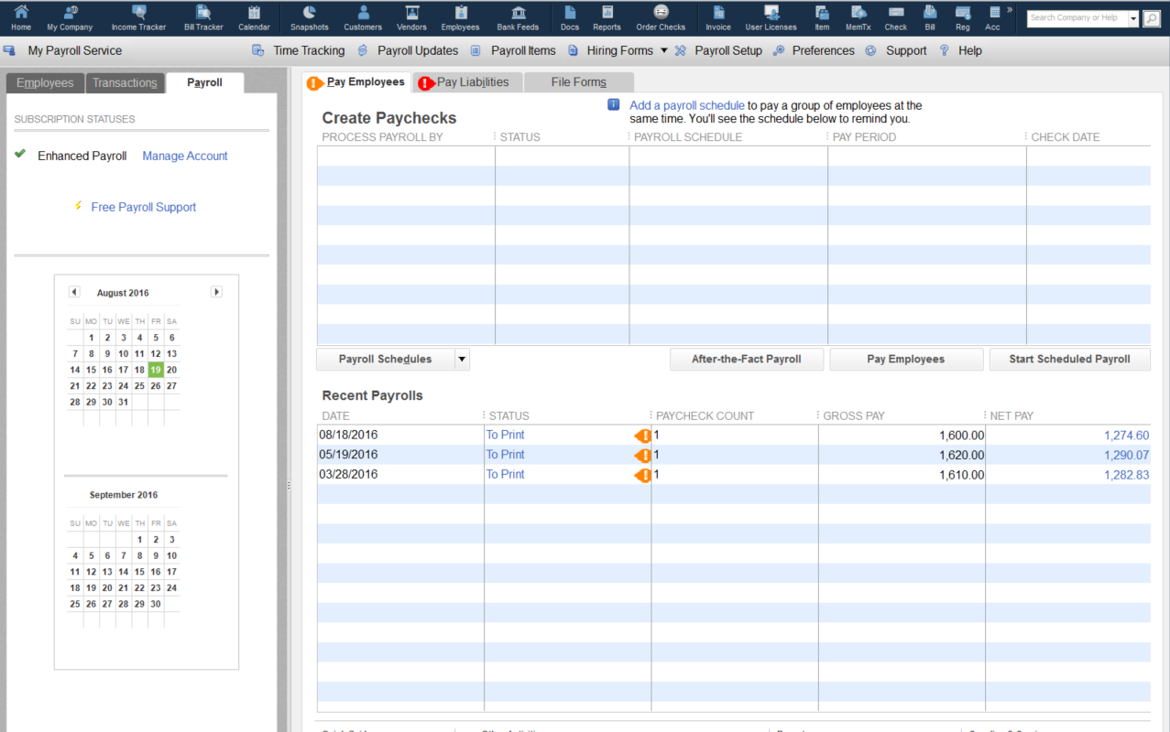

Create Paychecks
- Select Pay Employees button under Employee Center tab.

- Enter Payroll Information screen – review pay period, check date, bank account, and hours worked. Pay Period Ending Date and Check Date should be the same date! This will prevent conflicts with the scheduled liabilities screen!
- Select Employees to pay.
- Click Open Paycheck Detail, if necessary. (same paycheck screen as in former QB version)

Adjust hours worked when appropriate.

Select Open Paycheck Detail button to see details. (same as in former version)

Select Continue if paycheck detail is accurate.

Open Paycheck Detail Screen

Benefits are copied from the employee’s data file and are displayed under the section, Other Payroll Items.
Employee withholding and employer expenses are copied to sections, Employee Summary and Company Summary.

Benefits Adjustments (Edit Employee Data)
Before creating the next paycheck. employee and employer benefit adjustments should be made in the Employee’s data file instead of in the Preview Paycheck Screen.
- Select Employees from menu bar, Select Employee Center
- Select Employee Tab
- Select Employee Name, Click Edit Employee Button.
- Click the down arrow and change to Payroll and Compensation Info.
- Make appropriate changes and Save.
- Review and Create Paychecks. – summary of payroll data.
Caution - Create Paycheck button creates the paycheck transactions!!
This screen displays a summary of employee payroll data. You also have another opportunity to review the paycheck detail by selecting the Open Paycheck Detail button.

When you select Create Paychecks, you will be creating the paycheck transactions!!

Be certain all payroll details are correct before selecting the Create Paychecks button!!

Paycheck Options
Click Print paychecks from QuickBooks to have QuickBooks print the paychecks.
Click Assign check numbers to handwritten checks if you're writing your paychecks by hand or sending them to be deposited directly into the employees' account. Note: If you use direct deposit to pay your employees, you can leave the First Check Number field blank. This field can be used to enter a text memo (for example, DD or EFT), limited to 11 alphanumeric characters, which will print out on your employees' pay stubs. See section, “Direct Deposit-Paychecks” for details.
Direct Deposit – Paychecks
In your offices wants to schedule direct deposits of paychecks with the council’s bank, consult with the bank to determine if they offer this service free or for minimal fee. Do not select the Direct Deposit feature in the QuickBooks Preview Paycheck screen.
If you wish to utilize the Intuit Direct Deposit feature, review the procedure, Direct Deposits, section “Intuit (QuickBooks) Payroll Transfer.” The Direct Deposit feature in Quickbooks Preview Paycheck screen uses the Intuit direct deposit services. Intuit will charge a per-paycheck fee. Visit the Intuit Direct Deposit web site for latest fee charge.
Payroll – Printing Paychecks
After selecting the Create Paychecks button, the Confirmation and Next Steps window displays. You have the option of printing the paychecks immediately, or you can select the Close button to print the paychecks later. Go to File, Print Forms, Paychecks to print paychecks later.

Load checks in printer before selecting Print Paychecks button!

Payroll – Scheduled Payments
Payroll checks and liabilities can be grouped and setup for scheduled payments. If you have employees that are paid bi-weekly and other employees paid monthly, you can create scheduled payments for each group. The schedules may be established during the payroll setup with your regional QB administrator or later in the payroll center.

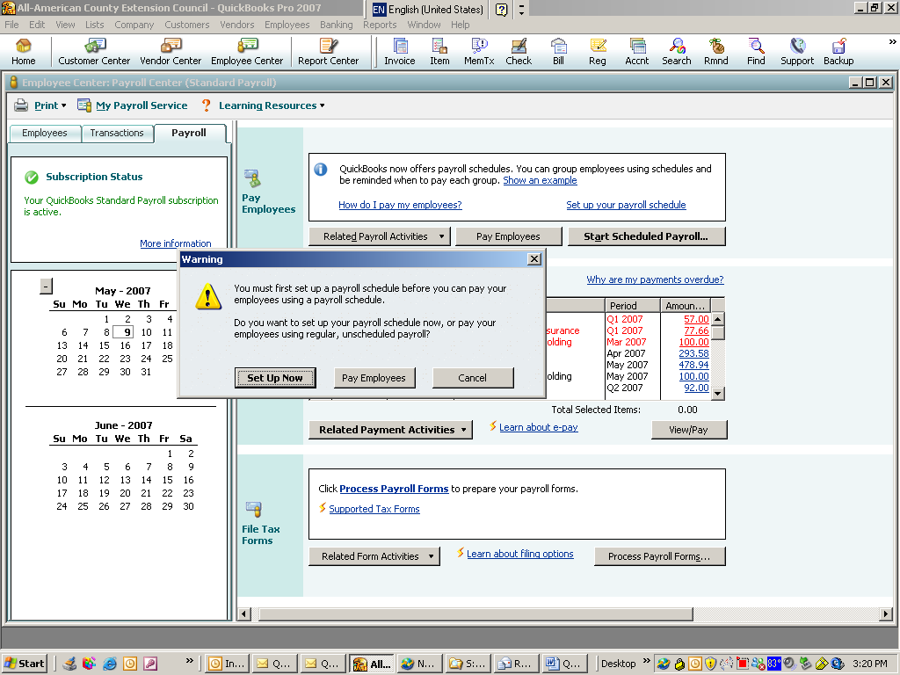
If you have only one or two employees, the Scheduled Payroll Check feature may not be beneficial. However, the Schedule Tax/Benefits Payment may be useful for bookkeepers.

Schedule Payroll Check Payment (optional)
- Under Payroll Tab, then under Pay Employees
- Select Start Scheduled Payroll button.
- Select Set Up Now button.

Here is a sample of the questions for creating a Payroll Check Schedule.

Sample of the questions for creating a Payroll check Schedule.

Schedule Tax/Benefit Payments (This feature may be useful for bookkeepers)
- Under Payroll Tab, then under Pay Scheduled Liabilities section.
- Select Related Payment Activities.
- Select Edit Payment Due Dates/Methods
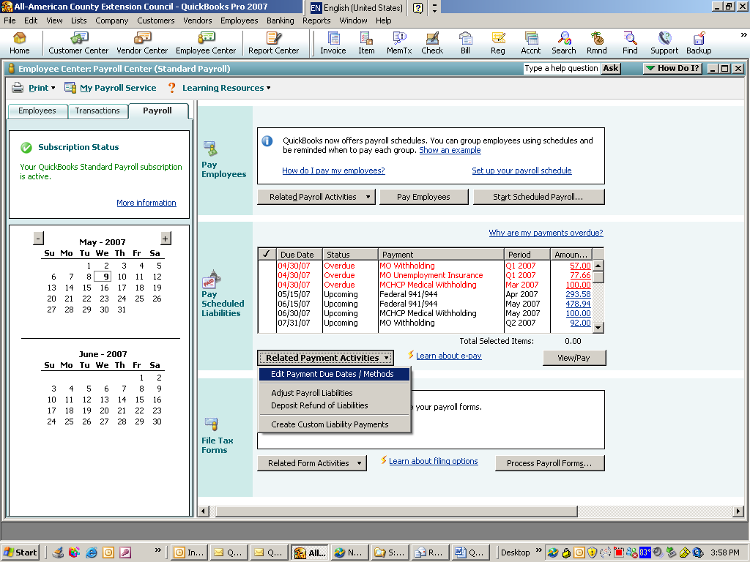

- Select Tax or Benefits Payments.
- Select appropriate payroll item. (remember also to schedule for both employee & employee contributions.
- Select Edit button

Example:

- Select appropriate Payment Frequency.
- Select “1” day of the month for the previous month’s liabilities.

