County Accounting Manual  Payroll Procedure Outline | Contents:  Quick Overview  How transactions are created
Important! Use the QB Payroll Screens to pay and print Employee paychecks and to pay and print Payroll Liability checks for both employee withholdings and employer expenses. Do NOT create paychecks and payroll liability checks in the Write Check Screen or directly in the Checking Register!!!!!

Here is a Quick Overview of the step-by-step Payroll Procedure.
For a list of all Payroll procedures, visit the Payroll link under the QuickBooks Procedures by Topics.
Payroll Item Setup (see procedure "Employer Payroll Items" for details)
- Edit Payroll Items (List, Payroll Items) to be certain that….
- All "company contributions" items are tracked by Job (and Class) under Edit, Preferences.
- Correct Payroll Vendor Name is identified.

Employee Data Setup (see procedure “Setting Up Employees” for details)
- Enter Employee Data (Employees, Employee Center, Edit employee)….
- Employee monthly or hourly salary
- employee tax and benefits withholdings
- employer-paid tax and benefit expenses
Pay Employees (see procedure “Prepare Employee Pay Checks” for details)
- Collect Employee Time Sheets, signed and approved by the appropriate supervisor.
- Employees (from menu bar), Payroll Center, Pay Employees
- Review bank account, pay period, check date
- Select the employee(s) to pay.
- Review Federal, Medicare, Social Security, State, and all Employee withholding amounts.
- Review Employer-Paid Medicare, Social Security and any benefit expenses in the "Company Summary" box.
- Make changes where necessary.
- Print Employee Paychecks.

Pay Payroll Liabilities (see procedure “Pay Payroll Taxes and Benefits” for details)
- Employees (from menu bar), select Payroll taxes and liabilities, select Create Custom Liability Payments.
- Select date range. Retain 01/01/<current year> for beginning date.
- Be sure "to be printed" is checked!!
- Select the Payroll Vendors to Pay. Most months, you will select all payroll vendors, except the State Withholding (which is paid quarterly).

Print Payroll Liability Checks
Once you select the Payroll Vendors to Pay, they are listed in the "Checks waiting to be printed" with other non-payroll checks.
- File, Print forms, Checks.

Process and Print 941 or 944 Form (see procedure “941,944 Tax Forms” for details)
- Employees (from menu bar), Payroll Center
- Click on File Forms tab
- Select the form and then click the Create tab
QB will print the data and the 94 1or 944 form, if your county is an “enhanced” payroll subscriber

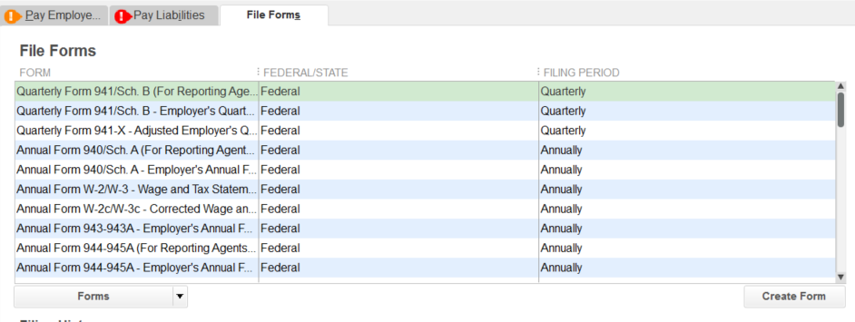

Process W₂ and W₃ Forms (see procedure “W2 Form Guidelines” for details)
- Employees (from menu bar), Payroll Center
- Click on File Forms tab
- Select the form and then click the Create tab
- Print W2 and W3 forms directly from QuickBooks, if you have the “enhanced” payroll subscription

How Payroll transactions are created

QuickBooks creates a transaction for each of the amounts listed below.

Employee Paycheck
Debit Credit
2730-Salary Expense 2,000.00
9010-Fed. Withholding Payable 100.00
9020-Soc.Sec.Tax Payable 124.00
9025-Medicare Tax Payable 29.00
9030-State Tax Payable 20.00
9055-MCHCP Medical payable 100.00
9070-Retirement PEBSCO Payable 20.00
0050-Checking Account (Cash) Net Pay 1,607.00

2820-Social Security Expense (employer) 124.00
9020-Soc.Sec.Tax Payable (employer) 124.00

2825-Medicare Tax Expense (employer) 29.00
9025-Medicare Tax Payable (employer) 29.00

2860-Retirement PEBSCO Expense (employer) 100.00
9070-Retirement PEBSCO Payable (employer) 100.00

2870-Missouri Unemployment Compensation 40.00
9095-Missouri Unemployment Payable 40.00

Class Tracking is recorded for all Expense account amounts under the Debit column.

Payroll Liability Check

Check for IRS Debit Credit
9010-Fed. Withholding Payable 100.00
9020-Soc.Sec. Tax Payable 124.00
9020-Soc.Sec. Tax Payable 124.00
9025-Medicare Tax Payable 29.00
9025-Medicare Tax Payable 29.00
0050-Checking Account (Cash) 406.00

Council may elect to pay federal taxes monthly online or pay quarterly taxes when submitting quarter 941 Federal form.

Check for Retirement Benefit
9070-Retirement PEBSCO Payable (employee) 20.00
9070-Retirement PEBSCO Payable (employer) 100.00
0050-Checking Account (Cash) 120.00

Check for Medical Benefit
9055-MCHCP Medical Payable (employee) 100.00
0050-Checking Account (Cash) 100.00

Check for State Tax Withholding
9030-State Tax Payable 20.00
0050-Checking Account (Cash) 20.00

Check for State Unemployment Tax
9095-Missouri Unemployment Payable 40.00
0050-Checking Account (Cash) 40.00

State Withholding Tax Payable and State Unemployment tax will increase each month until the end of the quarter when the total 3 months are paid, along with separate state tax forms.
All Payroll Liability check transactions use the 9xxx payroll liability accounts to offset the outstanding liabilities. No class code is assigned for payroll liabilities because the amounts are tracked by Class in the Payroll expense accounts, 2730 or 28xx.

