Outlook email rules

- In the Outlook Menu, click Tools—Rules and Alerts.

The Rules and Alerts screen should look like below.

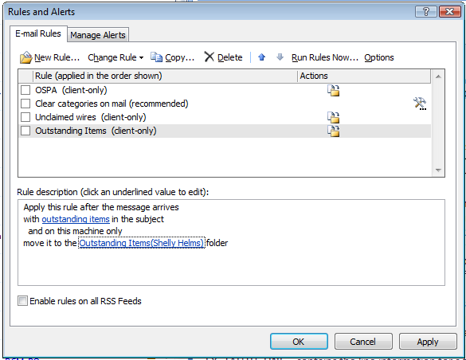

- Click the New Rule option. The box below should open. Highlight “Move messages with specific words in the subject to a folder” and click Next.

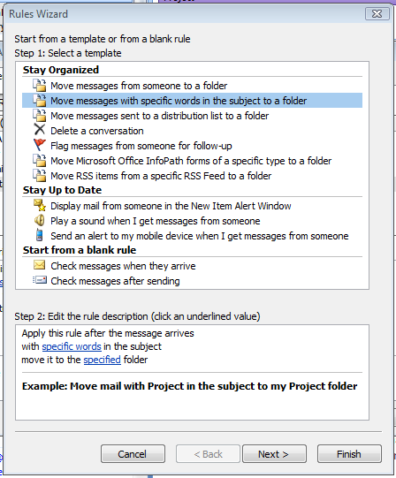

- Click “with specific words in the subject line” and “with specific words in the body.”

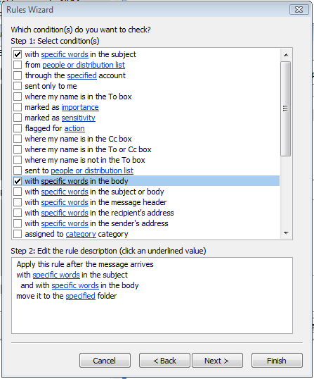

- Click on the hyperlink “specific words” in the subject. The box below should come up. Type “expense report” in the top box and click Add. Click OK.

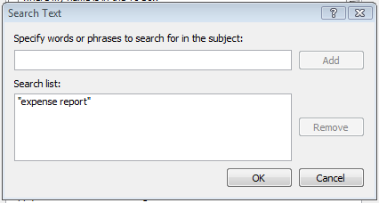

- Click on the hyperlink “specific words” in the body. The box below should come up. Type “You can navigate directly to” in the top box and click Add. Click OK.

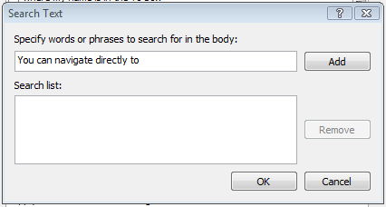

- Click on the hyperlink “specified”. Choose which Outlook folder you want the emails to go to and click OK. Back on the main screen, click Next.

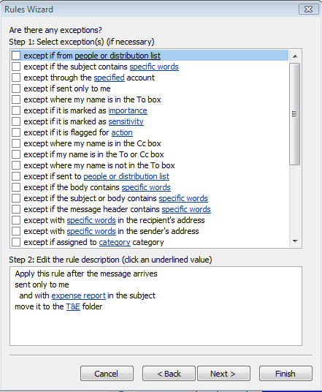

- At this point you have the option to add more options for which emails would go to that folder or stay in your inbox. When done, click Next.

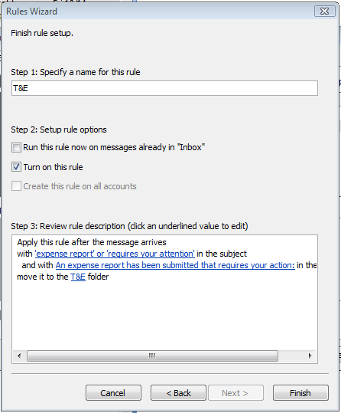

- Set the name for the rule and click Finish.

You are done!

