Outlook email rules

- In the Outlook Menu, click Tools—Rules and Alerts.

The Rules and Alerts screen should look like below.

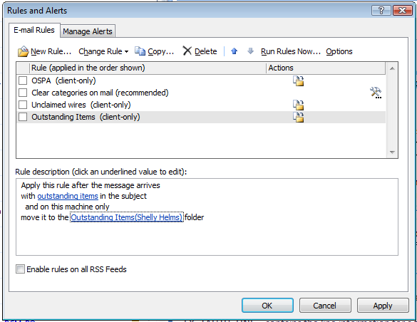

- Click the New Rule option. The box below should open. Highlight “Move messages with specific words in the subject to a folder” and click Next.

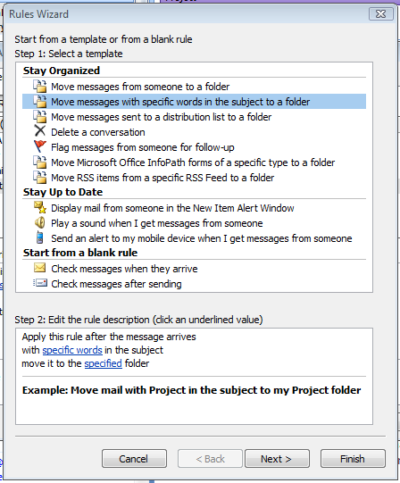

- Click “with specific words in the subject line” and “with specific words in the body.”

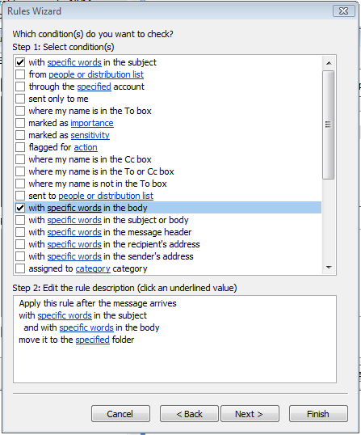

- Click on the hyperlink “specific words” in the subject. The box below should come up. Type “expense report” and “requires your attention” in the top box and click Add. Click OK.

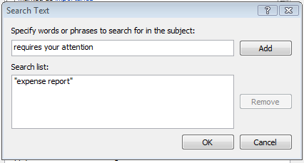

- Click on the hyperlink “specific words” in the body. The box below should come up. Type “An expense report has been submitted that requires your action:” and “You can navigate directly to the approval page by clicking the link below:” in the top box and click Add. Click OK.

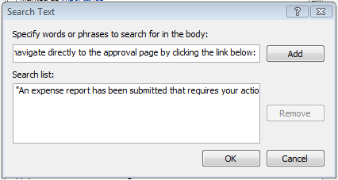

- Click on the hyperlink “specified”. Choose which Outlook folder you want the emails to go to and click OK. Back on the main screen, click Next.

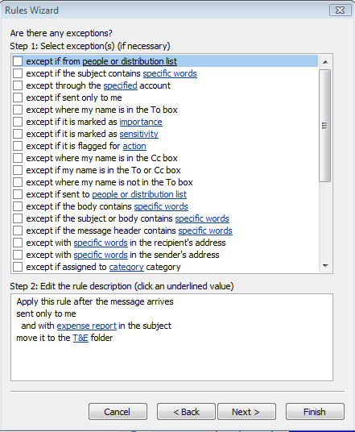

- At this point you have the option to add more options for which emails would go to that folder or stay in your inbox. When done, click Next.

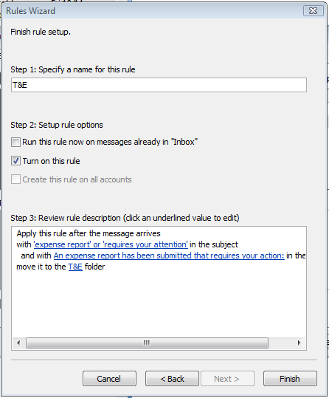

- Set the name for the rule and click Finish.

You are done!

